**SQL Training**

### Attention

1. The <XXXX> used in this article represents the employee ID. Please replace it with your own employee ID.

### Create data object

#### Create tables and table indexes

Table ：CUX_OM_CUSTOMERS_XXXX

For storing customer information。

| Field | Type | Nullable | Default Value | Description |
| --- | --- | --- | --- | --- |
|  |  |  |  |  |
| CUSTOMER_ID | BIGINT | N |  |  |
| CUSTOMER_NUMBER | VARCHAR(30) | N |  |  |
| CUSTOMER_NAME | VARCHAR(100) | N |  |  |
| TELEPHONE | VARCAHR(50) | Y |  |  |
| START_DATE_ACTIVE | DATE | Y |  |  |
| END_DATE_ACTIVE | DATE | Y |  |  |
| CREATED_BY | BIGINT | N |  |  |
| CREATION_DATE | DATE | N |  |  |
| LAST_UPDATED_BY | BIGINT | N |  |  |
| LAST_UPDATE_DATE | DATE | N |  |  |
| LAST_UPDATE_LOGIN | BIGINT | Y |  |  |

Create indexes：

| Index | Unique | Field | Description |
| --- | --- | --- | --- |
|  |  |  |  |
| CUX_OM_CUSTOMERS_XXXX_U1 | Y | CUSTOMER_ID |  |
| CUX_OM_CUSTOMERS_XXXX_U2 | Y | CUSTOMER_NUMBER |  |
| CUX_OM_CUSTOMERS_XXXX_U3 | Y | CUSTOMER_NAME |  |

Table：CUX_OM_ITEMS_XXXX

For storing product information。

| Field | Type | Nullable | Default Value | Description |
| --- | --- | --- | --- | --- |
|  |  |  |  |  |
| ITEM_ID | BIGINT | N |  |  |
| ITEM_NUMBER | VARCHAR(30) | N |  |  |
| ITEM_NAME | VARCHAR(100) | N |  |  |
| UOM_CODE | VARCHAR(25) | Y |  |  |
| START_DATE_ACTIVE | DATE | Y |  |  |
| END_DATE_ACTIVE | DATE | Y |  |  |
| CREATED_BY | BIGINT | N |  |  |
| CREATION_DATE | DATE | N |  |  |
| LAST_UPDATED_BY | BIGINT | N |  |  |
| LAST_UPDATE_DATE | DATE | N |  |  |
| LAST_UPDATE_LOGIN | BIGINT | Y |  |  |

Create indexes：

| Index | Unique | Field | Description |
| --- | --- | --- | --- |
|  |  |  |  |
| CUX_OM_ITEMS_XXXX_U1 | Y | ITEM_ID |  |
| CUX_OM_ITEMS_XXXX_U2 | Y | ITEM_NUMBER |  |

table：CUX_OM_HEADERS_XXXX

For storing sales order header information。

| Field | Type | Nullable | DefaultValue | Description |
| --- | --- | --- | --- | --- |
|  |  |  |  |  |
| HEADER_ID | BIGINT | N |  |  |
| ORG_ID | BIGINT | Y | 101 |  |
| ORDER_NUMBER | VARCHAR(30) | N |  |  |
| CUSTOMER_ID | BIGINT | Y |  |  |
| ORDER_DATE | DATE | N |  |  |
| ORDER_STATUS | VARCHAR(30) | Y |  | status list:  UNAPPROVED  APPROVED  CANCELLED  CLOSED |
| DESCRIPTION | VARCHAR(240) | Y |  |  |
| CREATED_BY | BIGINT | N |  |  |
| CREATION_DATE | DATE | N |  |  |
| LAST_UPDATED_BY | BIGINT | N |  |  |
| LAST_UPDATE_DATE | DATE | N |  |  |
| LAST_UPDATE_LOGIN | BIGINT | Y |  |  |
| ATTRIBUTE_CATEGORY | VARCHAR(30) | Y |  |  |
| ATTRIBUTE1 | VARCHAR(150) | Y |  |  |
| ATTRIBUTE2 | VARCHAR(150) | Y |  |  |
| ATTRIBUTE3 | VARCHAR(150) | Y |  |  |
| ATTRIBUTE4 | VARCHAR(150) | Y |  |  |
| ATTRIBUTE5 | VARCHAR(150) | Y |  |  |
| ATTRIBUTE6 | VARCHAR(150) | Y |  |  |
| ATTRIBUTE7 | VARCHAR(150) | Y |  |  |
| ATTRIBUTE8 | VARCHAR(150) | Y |  |  |
| ATTRIBUTE9 | VARCHAR(150) | Y |  |  |
| ATTRIBUTE10 | VARCHAR(150) | Y |  |  |
| ATTRIBUTE11 | VARCHAR(150) | Y |  |  |
| ATTRIBUTE12 | VARCHAR(150) | Y |  |  |
| ATTRIBUTE13 | VARCHAR(150) | Y |  |  |
| ATTRIBUTE14 | VARCHAR(150) | Y |  |  |
| ATTRIBUTE15 | VARCHAR(150) | Y |  |  |

Create Indexes：

| Index | Unique | Field | Description |
| --- | --- | --- | --- |
|  |  |  |  |
| CUX_OM_HEADERS_XXXX _U1 | Y | HEADER_ID |  |
| CUX_OM_HEADERS_XXXX _U2 | Y | ORDER_NUMBER |  |
| CUX_OM_HEADERS_XXXX _N1 |  | CUSTOMER_ID |  |

Table：CUX_OM_LINES_XXXX

For storing sales order line information。

| Field | Type | Nullable | Default Value | Description |
| --- | --- | --- | --- | --- |
|  |  |  |  |  |
| LINE_ID | BIGINT | N |  |  |
| HEADER_ID | BIGINT | N |  |  |
| LINE_NUMBER | VARCHAR(30) | N |  |  |
| ITEM_ID | BIGINT | N |  |  |
| UNIT_PRICE | DECIMAL(10,2) | Y |  |  |
| QUANTITY | DECIMAL(10,2) | Y |  |  |
| DESCRIPTION | VARCHAR(240) | Y |  |  |
| ADDITION1 | VARCHAR(150) | Y |  |  |
| ADDITION2 | VARCHAR(150) | Y |  |  |
| ADDITION3 | VARCHAR(150) | Y |  |  |
| ADDITION4 | VARCHAR(150) | Y |  |  |
| ADDITION5 | VARCHAR(150) | Y |  |  |
| CREATED_BY | BIGINT | N |  |  |
| CREATION_DATE | DATE | N |  |  |
| LAST_UPDATED_BY | BIGINT | N |  |  |
| LAST_UPDATE_DATE | DATE | N |  |  |
| LAST_UPDATE_LOGIN | BIGINT | Y |  |  |
| ATTRIBUTE_CATEGORY | VARCHAR(30) | Y |  |  |
| ATTRIBUTE1 | VARCHAR(150) | Y |  |  |
| ATTRIBUTE2 | VARCHAR(150) | Y |  |  |
| ATTRIBUTE3 | VARCHAR(150) | Y |  |  |
| ATTRIBUTE4 | VARCHAR(150) | Y |  |  |
| ATTRIBUTE5 | VARCHAR(150) | Y |  |  |
| ATTRIBUTE6 | VARCHAR(150) | Y |  |  |
| ATTRIBUTE7 | VARCHAR(150) | Y |  |  |
| ATTRIBUTE8 | VARCHAR(150) | Y |  |  |
| ATTRIBUTE9 | VARCHAR(150) | Y |  |  |
| ATTRIBUTE10 | VARCHAR(150) | Y |  |  |
| ATTRIBUTE11 | VARCHAR(150) | Y |  |  |
| ATTRIBUTE12 | VARCHAR(150) | Y |  |  |
| ATTRIBUTE13 | VARCHAR(150) | Y |  |  |
| ATTRIBUTE14 | VARCHAR(150) | Y |  |  |
| ATTRIBUTE15 | VARCHAR(150) | Y |  |  |

Create Indexes：

| Index | Unique | Field | Description |
| --- | --- | --- | --- |
|  |  |  |  |
| CUX_OM_LINES_XXXX _U1 | Y | LINE_ID |  |
| CUX_OM_LINES_XXXX _N1 |  | HEADER_ID |  |
| CUX_OM_LINES_XXXX _N2 |  | ITEM_ID |  |

#### Import data

excel：《1 – Table Data.xls》

1．CUX_OM_CUSTOMERS_XXXX

2．CUX_OM_ITEMS_XXXX

4．CUX_OM_HEADERS_XXXX

5．CUX_OM_LINES_XXXX

### Questions

#### NO.01

Please create the above objects in the database: table, table index。

-- Customer table

CREATE TABLE CUSTOMER (

CUSTOMER_ID BIGINT PRIMARY KEY,

CUSTOMER_NUMBER VARCHAR(50),

CUSTOMER_NAME VARCHAR(100),

TELEPHONE VARCHAR(20),

START_DATE_ACTIVE DATE,

END_DATE_ACTIVE DATE,

CREATED_BY BIGINT,

CREATION_DATE DATE,

LAST_UPDATED_BY BIGINT,

LAST_UPDATE_DATE DATE,

LAST_UPDATE_LOGIN BIGINT

);

INSERT INTO CUSTOMER (CUSTOMER_ID, CUSTOMER_NUMBER, CUSTOMER_NAME, TELEPHONE, START_DATE_ACTIVE, END_DATE_ACTIVE, CREATED_BY, CREATION_DATE, LAST_UPDATED_BY, LAST_UPDATE_DATE, LAST_UPDATE_LOGIN)

VALUES

(10001, '1101', '????????????', '020-28889382', '2013-10-01', NULL, '1', '2011-01-01', '1', '2011-01-01', '-1'),

(10002, '1102', 'Imaging Innovations, Inc.', '020-28889383', '2013-10-02', NULL, '1', '2011-01-01', '1', '2011-01-01', '-1'),

(10003, '1103', 'Federal Aviation Administration', '020-28889384', '2013-10-03', '2015-01-01', '1', '2011-01-01', '1', '2011-01-01', '-1'),

(10004, '1104', 'International Pottery', '020-28889385', '2013-10-04', NULL, '1', '2011-01-01', '1', '2011-01-01', '-1'),

(10005, '1105', 'Computer Service and Consulting', '020-28889386', '2013-10-05', NULL, '1', '2011-01-01', '1', '2011-01-01', '-1'),

(10006, '1106', 'A. C. Networks', '020-28889387', '2013-10-06', NULL, '1', '2011-01-01', '1', '2011-01-01', '-1'),

(10007, '1107', 'United Parcel Service', '020-28889388', '2013-10-07', '2015-01-10', '1', '2011-01-01', '1', '2011-01-01', '-1');

select * from customer;

drop table CUSTOMER;

-- Item table

CREATE TABLE ITEM (

ITEM_ID BIGINT PRIMARY KEY,

ITEM_NUMBER VARCHAR(30),

ITEM_NAME VARCHAR(100),

UOM_CODE VARCHAR(25),

START_DATE_ACTIVE DATE,

END_DATE_ACTIVE DATE,

CREATED_BY BIGINT,

CREATION_DATE DATE,

LAST_UPDATED_BY BIGINT,

LAST_UPDATE_DATE DATE,

LAST_UPDATE_LOGIN BIGINT

);

INSERT INTO ITEM (ITEM_ID, ITEM_NUMBER, ITEM_NAME, UOM_CODE, START_DATE_ACTIVE, END_DATE_ACTIVE, CREATED_BY, CREATION_DATE, LAST_UPDATED_BY, LAST_UPDATE_DATE, LAST_UPDATE_LOGIN)

VALUES

(10001, 'CM45470', '矿泉水', '瓶', '2013-10-01', NULL, '1', '2013-10-01', '1', '2013-10-01', '-1'),

(10002, 'CM45471', '桌子', '张', '2013-10-02', NULL, '1', '2013-10-01', '1', '2013-10-01', '-1'),

(10003, 'MC31324', '圆珠笔', '支', '2013-10-03', '2015-01-01', '1', '2013-10-01', '1', '2013-10-01', '-1'),

(10004, 'MC31325', '电脑', '台', '2013-10-04', NULL, '1', '2013-10-01', '1', '2013-10-01', '-1'),

(10005, 'MC31326', '硬盘', '个', '2013-10-05', NULL, '1', '2013-10-01', '1', '2013-10-01', '-1'),

(10006, 'MC31749', '玻璃', '公斤', '2013-10-06', NULL, '1', '2013-10-01', '1', '2013-10-01', '-1'),

(10007, 'MC31750', '投影仪', '台', '2013-10-07', '2015-10-01', '1', '2013-10-01', '1', '2013-10-01', '-1'),

(10008, 'SB86662', '办公用品', '个', '2013-10-08', NULL, '1', '2013-10-01', '1', '2013-10-01', '-1');

select * from item;

drop table ITEM;

-- Order header table

CREATE TABLE ORDER_HEADER (

HEADER_ID BIGINT PRIMARY KEY,

ORG_ID BIGINT,

ORDER_NUMBER VARCHAR(30),

CUSTOMER_ID BIGINT,

ORDER_DATE DATE,

ORDER_STATUS VARCHAR(20),

DESCRIPTION VARCHAR(255),

CREATED_BY BIGINT,

CREATION_DATE DATE,

LAST_UPDATED_BY BIGINT,

LAST_UPDATE_DATE DATE,

LAST_UPDATE_LOGIN BIGINT,

ATTRIBUTE_CATEGORY VARCHAR(30),

ATTRIBUTE1 VARCHAR(255),

ATTRIBUTE2 VARCHAR(255),

ATTRIBUTE3 VARCHAR(255),

ATTRIBUTE4 VARCHAR(255),

ATTRIBUTE5 VARCHAR(255),

ATTRIBUTE6 VARCHAR(255),

ATTRIBUTE7 VARCHAR(255),

ATTRIBUTE8 VARCHAR(255),

ATTRIBUTE9 VARCHAR(255),

ATTRIBUTE10 VARCHAR(255),

ATTRIBUTE11 VARCHAR(255),

ATTRIBUTE12 VARCHAR(255),

ATTRIBUTE13 VARCHAR(255),

ATTRIBUTE14 VARCHAR(255),

ATTRIBUTE15 VARCHAR(255)

);

INSERT INTO ORDER_HEADER (HEADER_ID, ORG_ID, ORDER_NUMBER, CUSTOMER_ID, ORDER_DATE, ORDER_STATUS, DESCRIPTION, CREATED_BY, CREATION_DATE, LAST_UPDATED_BY, LAST_UPDATE_DATE, LAST_UPDATE_LOGIN, ATTRIBUTE_CATEGORY, ATTRIBUTE1, ATTRIBUTE2, ATTRIBUTE3, ATTRIBUTE4, ATTRIBUTE5, ATTRIBUTE6, ATTRIBUTE7, ATTRIBUTE8, ATTRIBUTE9, ATTRIBUTE10, ATTRIBUTE11, ATTRIBUTE12, ATTRIBUTE13, ATTRIBUTE14, ATTRIBUTE15)

VALUES

(10001, 101, '1000000001', 10001, '2015-01-01', 'CANCELLED', NULL, 206, '2013-10-01', 1, '2013-10-01', -1, NULL, NULL, NULL, NULL, NULL, NULL, NULL, NULL, NULL, NULL, NULL, NULL, NULL, NULL, NULL, NULL),

(10002, 101, '1000000002', 10002, '2015-02-01', 'NEW', NULL, 206, '2013-10-01', 1, '2013-10-01', -1, NULL, NULL, NULL, NULL, NULL, NULL, NULL, NULL, NULL, NULL, NULL, NULL, NULL, NULL, NULL, NULL),

(10003, 101, '1000000003', 10003, '2015-03-01', 'APPROVED', NULL, 206, '2013-10-01', 1, '2013-10-01', -1, NULL, NULL, NULL, NULL, NULL, NULL, NULL, NULL, NULL, NULL, NULL, NULL, NULL, NULL, NULL, NULL),

(10004, 101, '1000000004', 10004, '2015-04-01', 'CANCELLED', NULL, 107, '2013-10-01', 1, '2013-10-01', -1, NULL, NULL, NULL, NULL, NULL, NULL, NULL, NULL, NULL, NULL, NULL, NULL, NULL, NULL, NULL, NULL),

(10005, 101, '1000000005', 10005, '2016-05-01', 'CLOSED', NULL, 107, '2013-10-01', 1, '2013-10-01', -1, NULL, NULL, NULL, NULL, NULL, NULL, NULL, NULL, NULL, NULL, NULL, NULL, NULL, NULL, NULL, NULL),

(10006, 101, '1000000006', 10006, '2015-06-01', 'APPROVED', NULL, 107, '2013-10-01', 1, '2013-10-01', -1, NULL, NULL, NULL, NULL, NULL, NULL, NULL, NULL, NULL, NULL, NULL, NULL, NULL, NULL, NULL, NULL),

(10007, 101, '1000000007', 10007, '2015-07-01', 'UNAPPROVED', NULL, 107, '2013-10-01', 1, '2013-10-01', -1, NULL, NULL, NULL, NULL, NULL, NULL, NULL, NULL, NULL, NULL, NULL, NULL, NULL, NULL, NULL, NULL),

(10008, 101, '1000000008', 10001, '2015-08-01', 'APPROVED', NULL, 176, '2013-10-01', 1, '2013-10-01', -1, NULL, NULL, NULL, NULL, NULL, NULL, NULL, NULL, NULL, NULL, NULL, NULL, NULL, NULL, NULL, NULL),

(10009, 101, '1000000009', 10002, '2015-09-01', 'APPROVED', NULL, 176, '2013-10-01', 1, '2013-10-01', -1, NULL, NULL, NULL, NULL, NULL, NULL, NULL, NULL, NULL, NULL, NULL, NULL, NULL, NULL, NULL, NULL),

(10010, 101, '1000000010', 10003, '2015-10-01', 'CANCELLED', NULL, 176, '2013-10-01', 1, '2013-10-01', -1, NULL, NULL, NULL, NULL, NULL, NULL, NULL, NULL, NULL, NULL, NULL, NULL, NULL, NULL, NULL, NULL),

(10011, 101, '1000000011', 10004, '2015-11-01', 'APPROVED', NULL, 176, '2013-10-01', 1, '2013-10-01', -1, NULL, NULL, NULL, NULL, NULL, NULL, NULL, NULL, NULL, NULL, NULL, NULL, NULL, NULL, NULL, NULL),

(10012, 101, '1000000012', 10005, '2015-07-01', 'CLOSED', NULL, 176, '2013-10-01', 1, '2013-10-01', -1, NULL, NULL, NULL, NULL, NULL, NULL, NULL, NULL, NULL, NULL, NULL, NULL, NULL, NULL, NULL, NULL),

(10013, 101, '1000000013', 10006, '2016-08-01', 'UNAPPROVED', NULL, 202, '2013-10-01', 1, '2013-10-01', -1, NULL, NULL, NULL, NULL, NULL, NULL, NULL, NULL, NULL, NULL, NULL, NULL, NULL, NULL, NULL, NULL),

(10014, 101, '1000000014', 10007, '2015-09-01', 'CLOSED', NULL, 202, '2013-10-01', 1, '2013-10-01', -1, NULL, NULL, NULL, NULL, NULL, NULL, NULL, NULL, NULL, NULL, NULL, NULL, NULL, NULL, NULL, NULL);

select * from order_header;

drop table ORDER_HEADER;

-- Order line table

CREATE TABLE ORDER_LINE (

LINE_ID BIGINT PRIMARY KEY,

HEADER_ID BIGINT,

LINE_NUMBER BIGINT,

CUSTOMER_ID BIGINT,

ITEM_ID BIGINT,

UNIT_PRICE DECIMAL(10, 2),

QUANTITY DECIMAL(10, 2),

DESCRIPTION VARCHAR(255),

ADDITION1 VARCHAR(255),

ADDITION2 VARCHAR(255),

ADDITION3 VARCHAR(255),

ADDITION4 VARCHAR(255),

ADDITION5 VARCHAR(255),

CREATED_BY VARCHAR(50),

CREATION_DATE TIMESTAMP,

LAST_UPDATED_BY BIGINT,

LAST_UPDATE_DATE DATE,

LAST_UPDATE_LOGIN BIGINT,

ATTRIBUTE_CATEGORY VARCHAR(30),

ATTRIBUTE1 VARCHAR(255),

ATTRIBUTE2 VARCHAR(255),

ATTRIBUTE3 VARCHAR(255),

ATTRIBUTE4 VARCHAR(255),

ATTRIBUTE5 VARCHAR(255),

ATTRIBUTE6 VARCHAR(255),

ATTRIBUTE7 VARCHAR(255),

ATTRIBUTE8 VARCHAR(255),

ATTRIBUTE9 VARCHAR(255),

ATTRIBUTE10 VARCHAR(255),

ATTRIBUTE11 VARCHAR(255),

ATTRIBUTE12 VARCHAR(255),

ATTRIBUTE13 VARCHAR(255),

ATTRIBUTE14 VARCHAR(255),

ATTRIBUTE15 VARCHAR(255)

);

select * from order_line;

drop table order_line;

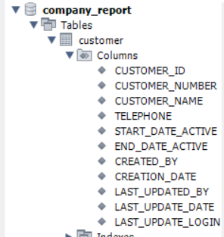

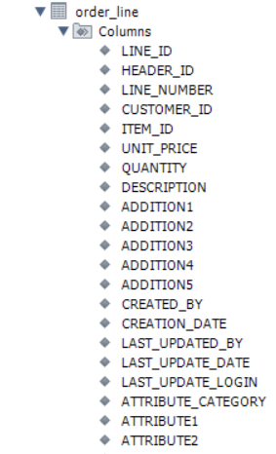

#### NO.02

Please import the corresponding table data in the file: "1 – Table Data.xlsx" into the table。

#### NO.03

Create a view：CUX_OM_HEADERS_V

* view：CUX_OM_HEADERS_V

CREATE VIEW ORDER_VIEW AS

SELECT OH.HEADER_ID, OH.ORDER_NUMBER, OH.CUSTOMER_ID, OH.ORDER_DATE, OH.ORDER_STATUS, OH.DESCRIPTION,

OH.CREATED_BY, OH.CREATION_DATE, OH.LAST_UPDATED_BY, OH.LAST_UPDATE_DATE, OH.LAST_UPDATE_LOGIN,

OH.ATTRIBUTE_CATEGORY, OH.ATTRIBUTE1, OH.ATTRIBUTE2, OH.ATTRIBUTE3, OH.ATTRIBUTE4,

OH.ATTRIBUTE5, OH.ATTRIBUTE6, OH.ATTRIBUTE7, OH.ATTRIBUTE8, OH.ATTRIBUTE9, OH.ATTRIBUTE10,

OH.ATTRIBUTE11, OH.ATTRIBUTE12, OH.ATTRIBUTE13, OH.ATTRIBUTE14, OH.ATTRIBUTE15,

C.CUSTOMER_NUMBER, C.CUSTOMER_NAME, C.TELEPHONE

FROM ORDER_HEADER OH

JOIN CUSTOMER C ON OH.CUSTOMER_ID = C.CUSTOMER_ID;

select * from order_view

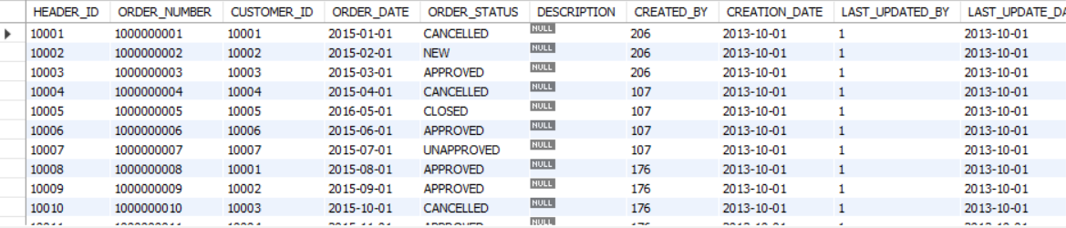

| Field | Type | Nullable | DefaultValue | Description |
| --- | --- | --- | --- | --- |
|  |  |  |  |  |
| HEADER_ID | BIGINT | N |  |  |
| ORDER_NUMBER | VARCHAR(30) | N |  |  |
| CUSTOMER_ID | BIGINT | Y |  |  |
| ORDER_DATE | DATE | N |  |  |
| ORDER_STATUS | VARCHAR(30) | Y |  | status list:  UNAPPROVED  APPROVED  CANCELLED  CLOSED |
| DESCRIPTION | VARCHAR(240) | Y |  |  |
| CREATED_BY | BIGINT | N |  |  |
| CREATION_DATE | DATE | N |  |  |
| LAST_UPDATED_BY | BIGINT | N |  |  |
| LAST_UPDATE_DATE | DATE | N |  |  |
| LAST_UPDATE_LOGIN | BIGINT | Y |  |  |
| ATTRIBUTE_CATEGORY | VARCHAR(30) | Y |  |  |
| ATTRIBUTE1 | VARCHAR(150) | Y |  |  |
| ATTRIBUTE2 | VARCHAR(150) | Y |  |  |
| ATTRIBUTE3 | VARCHAR(150) | Y |  |  |
| ATTRIBUTE4 | VARCHAR(150) | Y |  |  |
| ATTRIBUTE5 | VARCHAR(150) | Y |  |  |
| ATTRIBUTE6 | VARCHAR(150) | Y |  |  |
| ATTRIBUTE7 | VARCHAR(150) | Y |  |  |
| ATTRIBUTE8 | VARCHAR(150) | Y |  |  |
| ATTRIBUTE9 | VARCHAR(150) | Y |  |  |
| ATTRIBUTE10 | VARCHAR(150) | Y |  |  |
| ATTRIBUTE11 | VARCHAR(150) | Y |  |  |
| ATTRIBUTE12 | VARCHAR(150) | Y |  |  |
| ATTRIBUTE13 | VARCHAR(150) | Y |  |  |
| ATTRIBUTE14 | VARCHAR(150) | Y |  |  |
| ATTRIBUTE15 | VARCHAR(150) | Y |  |  |
| CUSTOMER_NUMBER | VARCHAR(30) |  |  |  |
| CUSTOMER_NAME | VARCHAR(100) |  |  |  |
| TELEPHONE | VARCHAR(50) | Y |  |  |

#### NO.04

Write SQL to display the following information and sort it by customer_number and order_number in ascending order。

select o.ORDER_NUMBER, c.CUSTOMER_NUMBER, c.CUSTOMER_NAME, o.ORDER_DATE, o.ORDER_STATUS, o.DESCRIPTION

from customer c

join order_header o

on c.CUSTOMER_ID = o.CUSTOMER_ID

order by o.ORDER_NUMBER asc;

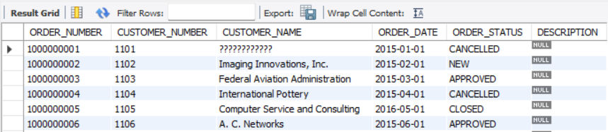

|  |  |  |  |  |  |
| --- | --- | --- | --- | --- | --- |
| order_number | customer_number | customer_name | order_date | order_status | description |
|  |  |  |  |  |  |
|  |  |  |  |  |  |

#### NO.05

Write SQL to display order and order line information, sorted by order number and line number in ascending order (including orders with all statuses)

select oh.ORDER_NUMBER, c.CUSTOMER_NAME, oh.ORDER_DATE, oh.ORDER_STATUS, ol.LINE_NUMBER, i.ITEM_NAME

from order_header oh

join order_line ol

on oh.HEADER_ID = ol.HEADER_ID

join item i

on i.ITEM_ID = ol.ITEM_ID

join customer c

on oh.CUSTOMER_ID = c.CUSTOMER_ID;

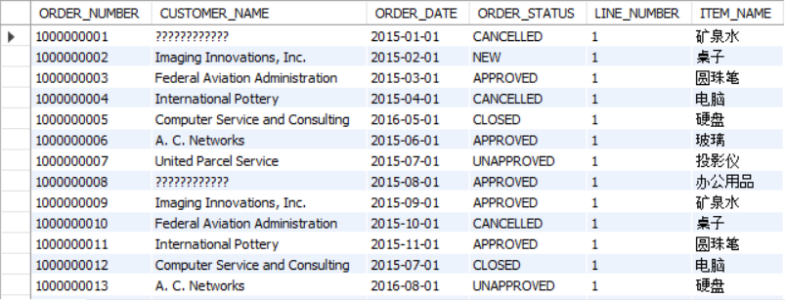

|  |  |  |  |  |  |  |
| --- | --- | --- | --- | --- | --- | --- |
| order_number | customer_name | order_date | order_status | line_number | item_number | item_name |
|  |  |  |  |  |  |  |

#### NO.06

Write SQL to display products purchased by customers

select c.CUSTOMER_NUMBER, c.CUSTOMER_NAME, i.ITEM_NUMBER, i.ITEM_NAME, i.UOM_CODE

from customer c

join order_header oh

on c.CUSTOMER_ID = oh.CUSTOMER_ID

join order_line ol

on ol.HEADER_ID = oh.HEADER_ID

join item i

on i.ITEM_ID = ol.ITEM_ID;

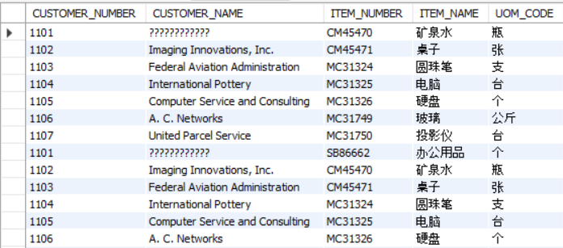

|  |  |  |  |  |
| --- | --- | --- | --- | --- |
| customer_number | customer_number | item_number | item_name | uom_code |
| 1101 | 汉得信息技术股份有限公司 | SB86662 | 办公用品 | 个 |

#### NO.07

Write SQL to count all orders (excluding canceled orders) and calculate the average sales unit price and the highest and lowest unit price by product.

select i.ITEM_NUMBER, i.ITEM_NAME, avg(ol.ITEM_ID) as average_unit_price, max(ol.ITEM_ID) as highest_unit_price, min(ol.ITEM_ID) as lowest_unit_price

from item i

join order_line ol

on i.ITEM_ID = ol.ITEM_ID

join order_header oh

on oh.HEADER_ID = ol.HEADER_ID

group by ol.ITEM_ID;

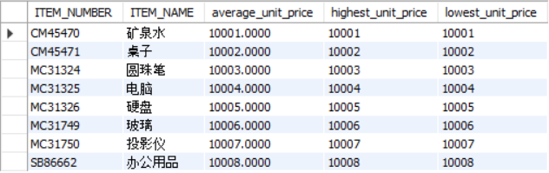

|  |  |  |  |  |
| --- | --- | --- | --- | --- |
| item_number | item_name | average_unit_price | highest_unit_price | lowest_unit_price |
|  |  |  |  |  |

#### NO.08

Write SQL to query customer information about canceled orders.

select c.CUSTOMER_NUMBER, c.CUSTOMER_NAME, c.TELEPHONE, c.START_DATE_ACTIVE, c.END_DATE_ACTIVE

from customer c

join order_header o

on c.CUSTOMER_ID = o.CUSTOMER_ID

where o.ORDER_STATUS = "CANCELLED";  
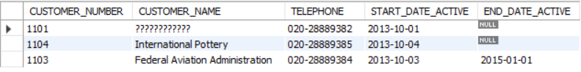

|  |  |  |  |  |
| --- | --- | --- | --- | --- |
| customer_number | customer_name | telephone | start_date_active | end_date_active |
|  |  |  |  |  |

#### NO.09

Write SQL to count the company's total sales in 2015. (All orders with status CANCELLED are excluded from statistics)

select sum(ol.UNIT_PRICE) * sum(ol.QUANTITY) as "Total Sales"

from order_header oh

join order_line ol

where year(oh.order_date) and oh.ORDER_STATUS != "CANCELLED";



|  |
| --- |
| Total Sales |
|  |

#### NO.10

Write a script to add an index to the table: CUX_OM_ITEMS_XXXX: a normal index, and the applicable field: ITEM_NAME.

CREATE INDEX idx_item_name ON item (ITEM_NAME);  
